**Multiple Implementation BADI**

1. Go to tcode SE18.Give a BADI name starting with Z/X. Go to Utilities->Create Classic BADI.

(Do not click create)

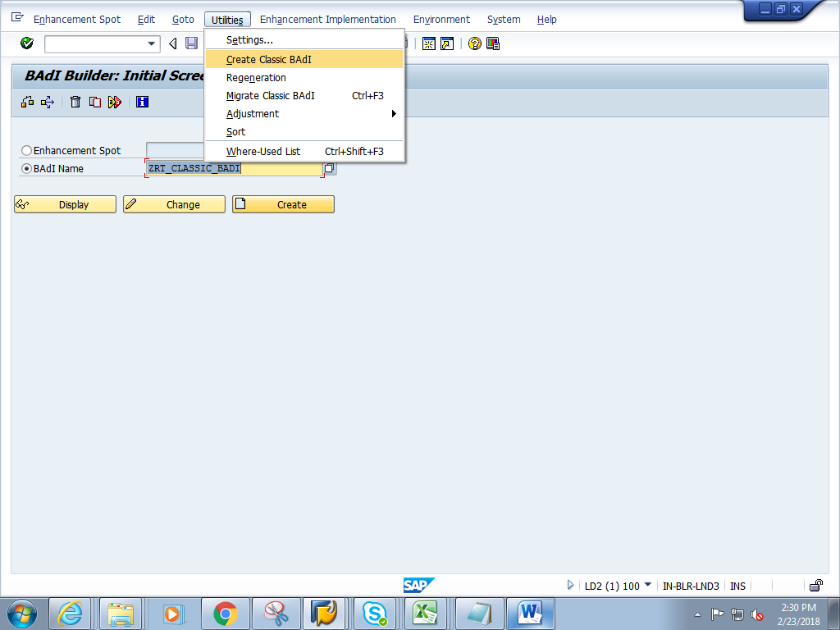

1. Give a short description. **Check on the Multiple Use and Filter Depend**Give Filter type as data element name **S_CARR_ID.**

Click on Interface tab

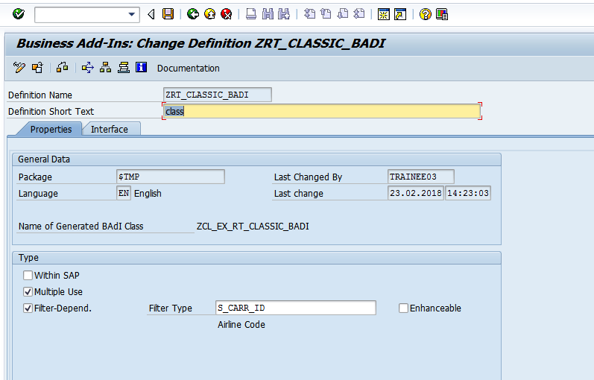

1. Double click on the interface.

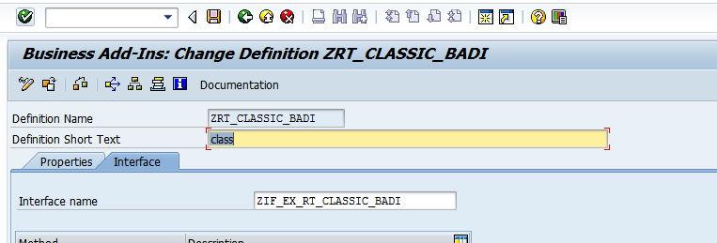

1. In the interface, add the method meth_Sflight as shown below. And add two parameters

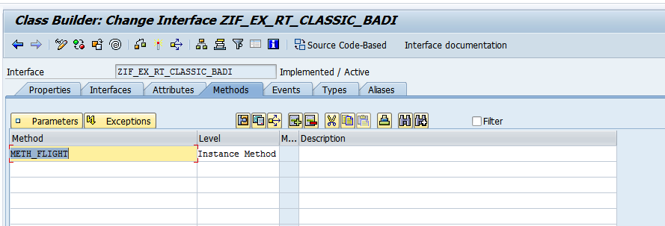

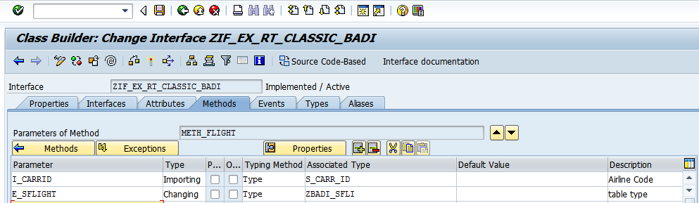

1. Save and activate the BADI defintion
2. Go to se19 - Give BADI definitioan name click on create. 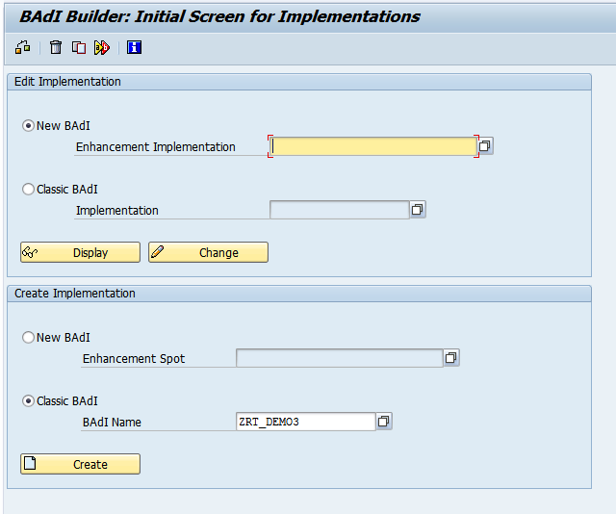
3. Create implementation 1 for the BADI

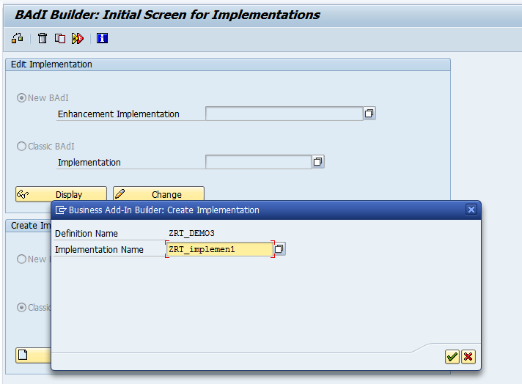

1. Give short description click on interface tab

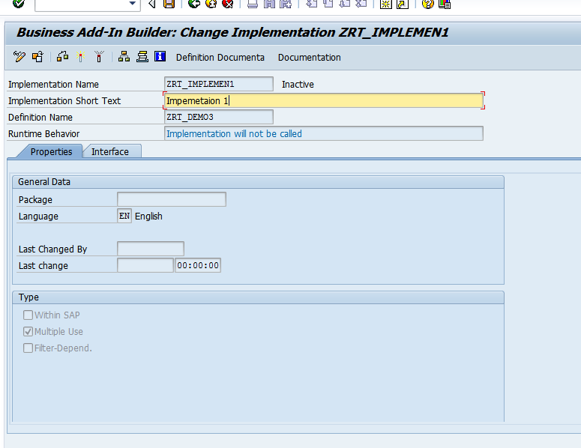

1. In the method ,add the below code.

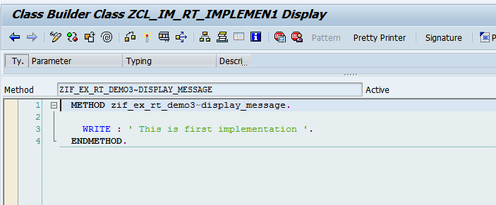

1. Save and activate the method , implementation. Go back.
2. Create implementation 2 from se19 ( Refer to steps from step 7 to step 9).

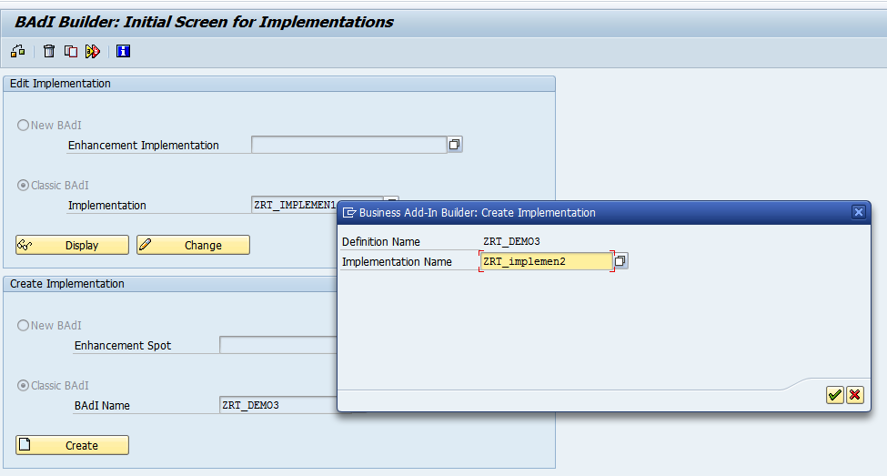

1. In the method of the second implemetation , add the below code

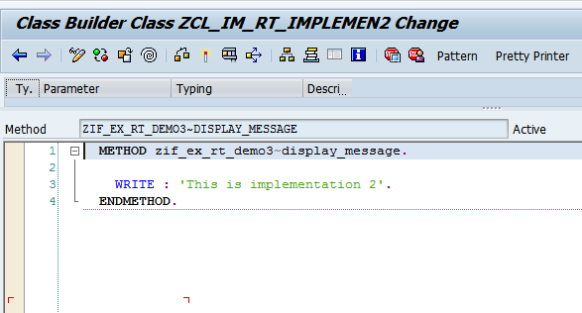

1. Save and activate the method ,second implementation

